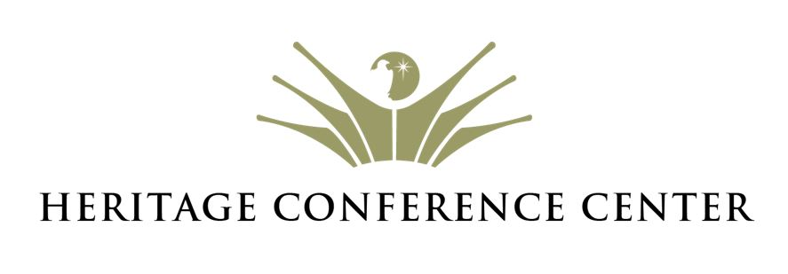

Alcohol Policy

PURPOSE

Heritage Conference Center and its facilities are primarily designed to provide a “Christian retreat” environment and as such are not suitable for occasions that are not in alignment with this purpose. It is understood that the use of alcoholic beverages for occasional, celebratory events may be a desired component of events hosted by persons seeking to use Heritage Conference Center facilities. At no time do we desire any abuse of alcoholic beverage consumption. For these purposes, we have designed this policy concerning alcoholic beverages on the premises to help safeguard all involved.

PRECAUTIONS AND LIMITATIONS

  - Any alcoholic beverages served at events booked at Heritage Conference Center must be served according to this policy and all current laws and ordinances that apply to this jurisdiction.
  - Hard liquor may not be served at Heritage Conference Center events without express permission from Executive Management.
  - Any alcohol brought on the premises, including the parking areas, by any individual not authorized specifically by Heritage Conference Center staff will be confiscated and the offending party may be asked to leave the premises. Any instance will result in an immediate forfeiture of the associated deposit.

BOOKING PARTY RESPONSIBILITIES

  - Booking party agrees to limit alcohol consumption to two drinks per guest. Serving size of a drink is limited to 6 oz. of wine or 12 oz. of beer. An additional toast is allowed.
  - Beer and/or wine will be purchased by booking party (not by Heritage Conference Center) and is to be delivered to the wedding one (1) week prior to the wedding date.
  - A charge of $150 per event will be paid by booking party toward usage, handling, insurance, and services.
  - A deposit of $500 per event will be paid by booking party upon signature of alcohol policy. Upon completion of event, the $500 deposit will be returned to the client, provided all policy and procedures are adhered to. Failure on the part of the booking party to comply with policies herein will result in forfeiture of deposit.
  - It is the booking party’s responsibility to ensure that each member of the booking party, each of their guests, staff, or contractors, understand and comply with this alcohol policy. The refund of the alcohol policy deposit will be made at the sole discretion of Heritage Conference Center staff.

IMPORTANT NOTICE

The alcohol provision deposit will not be refunded and will be forfeited by the booking party in its entirety if any of the following occur by any of the booking party’s guests, staff, contractors, or organizers:
- Alcohol consumption by anyone under the legal drinking age of twenty-one (21) years
- Visible signs of intoxication
- Failure to comply with any provisions of this alcohol policy.

GUIDELINES

- No beer and/or wine will be sold on the property or given away for a donation
- Beer and/or wine may be served at private events closed to the general public when proof of a guest list or a sent invitation list exists
- Beer and/or wine will be purchased by booking party (not by Heritage Conference Center)
- Beer and/or wine will be served from one designated location by a qualified server provided by the Heritage Conference Center.
- Signing parties will adhere to the above policy and conditions

___________________________ __________________________
Booking Party Signature Date

___________________________ __________________________
Sales Manager Signature Date

Other exclusions and limitations may apply for all events held at Heritage Conference Center. All event details, client expectations, and event charges will be discussed with the client prior to policy signing. Please speak with your event coordinator if you have any questions, comments, or concerns related to the policies and guidelines of Heritage Conference Center.

